- Please add the blue banner on this text :

- Can you please move the fund name into the blue banner at the top (WB_Pastperformancenarrative1)
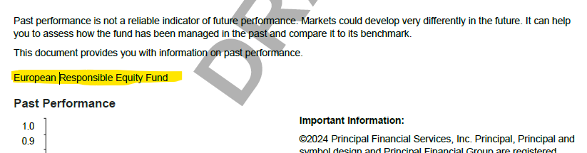
- Can you please move this text behind the graph ?

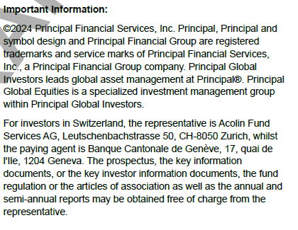

- Can you please these 2 sentences as per example:
Our template:
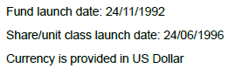
Client template:

